Inspiration4 Sends “Ordinary People” to Space
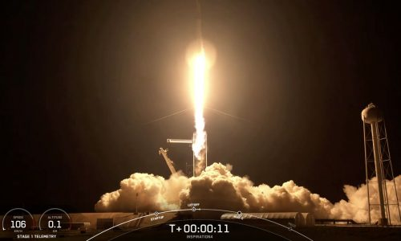
A group of four “ordinary” people blasted off into space. This was the first space mission with no professional astronauts, and the mission is called Inspiration4. They were in space for three days and circled around the Earth more than 15 times each day.
An idea
Inspiration4 was an idea of billionaire Jared Isaacman. He paid a lot of money to Elon Musk (the owner of Tesla and the company SpaceX) to make this mission possible. Jared Isaacman wanted to use this trip to raise money for St. Jude Children’s Research Hospital (an organization that help children who have cancer).
The Inspiration4 crew
The capsule they were in had room for four crew members. The crew was:
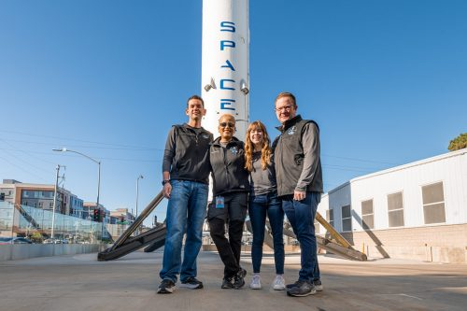
- Jared Isaacman – His idea
- Dr. Sian Proctor – She is a professor who nearly became a NASA astronaut in 2009.
- Haley Arceneaux – She was a cancer patient at St. Jude Hospital when she was young. Now she works at the hospital.
- Chris Sembroski – He has worked in the US Air Force.

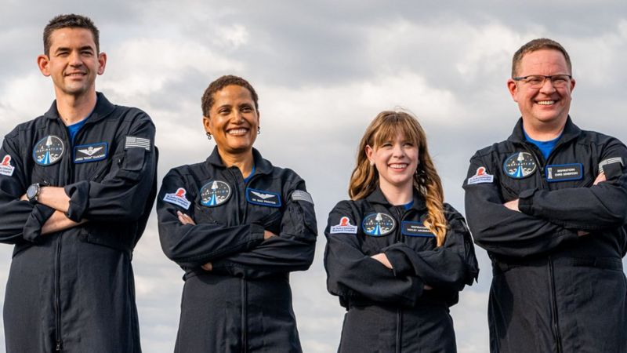
Why these people?
Jared paid for the mission. Dr. Sian won a contest held by Jared Isaacman’s company. Haley was chosen by her workplace St. Jude Hospital. Chris now works as an engineer with an aerospace company.
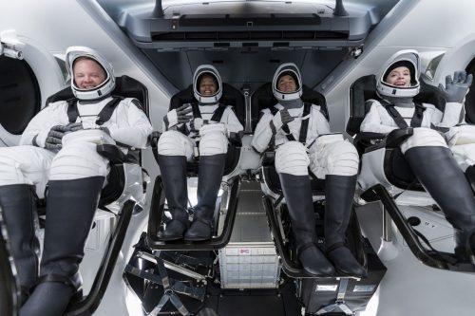
Preparing and experimenting
This is the first “all amateur” flight ever, but the crew members have a lot of knowledge and experience that will be helpful. They have also had a six-month astronaut training course. The picture shows Inspiration4 crew members practice for take-off.
The crew had some experiments to work on while they were in space. Experts back home took notes of the crew’s blood oxygen level and sleep to find out more how ordinary people’s bodies can react to a space trip.

“Space tourism”
Jared Isaacman wants this mission to also open up space for ordinary tourists. He says: “I truly want us to live in a world 50 or 100 years from now, where families are jumping around on the moon in a spacesuit”.
For now, only billionaires has money to fly to space, but it is expected to get cheaper. Flying airplane was also very expensive, but now almost everyone can travel by plane.

Mission Complete!
The four amateur astronauts returned to Earth with a splash on September 18th 2021.
